Experiment No.: 4
Title: Use function types, scope, and closures; apply try-catch; build a palindrome checker.
Software/Tools Required: HTML5, CSS3, JavaScript, VS Code, Google Chrome
Theory: Functions help organize reusable code, while scope determines variable accessibility and closures allow functions to retain access to outer-scope variables. try-catch handles runtime errors safely. A palindrome checker compares a string with its reverse to determine whether it reads the same forward and backward.
Output:
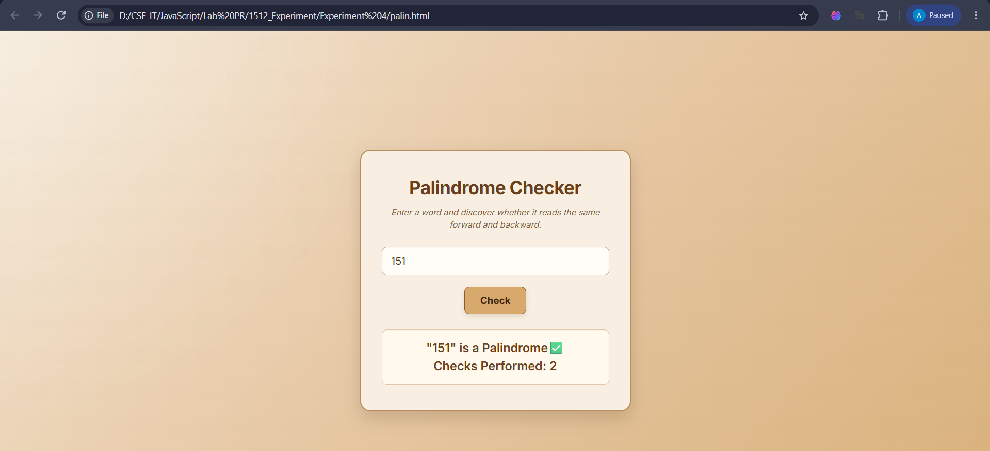
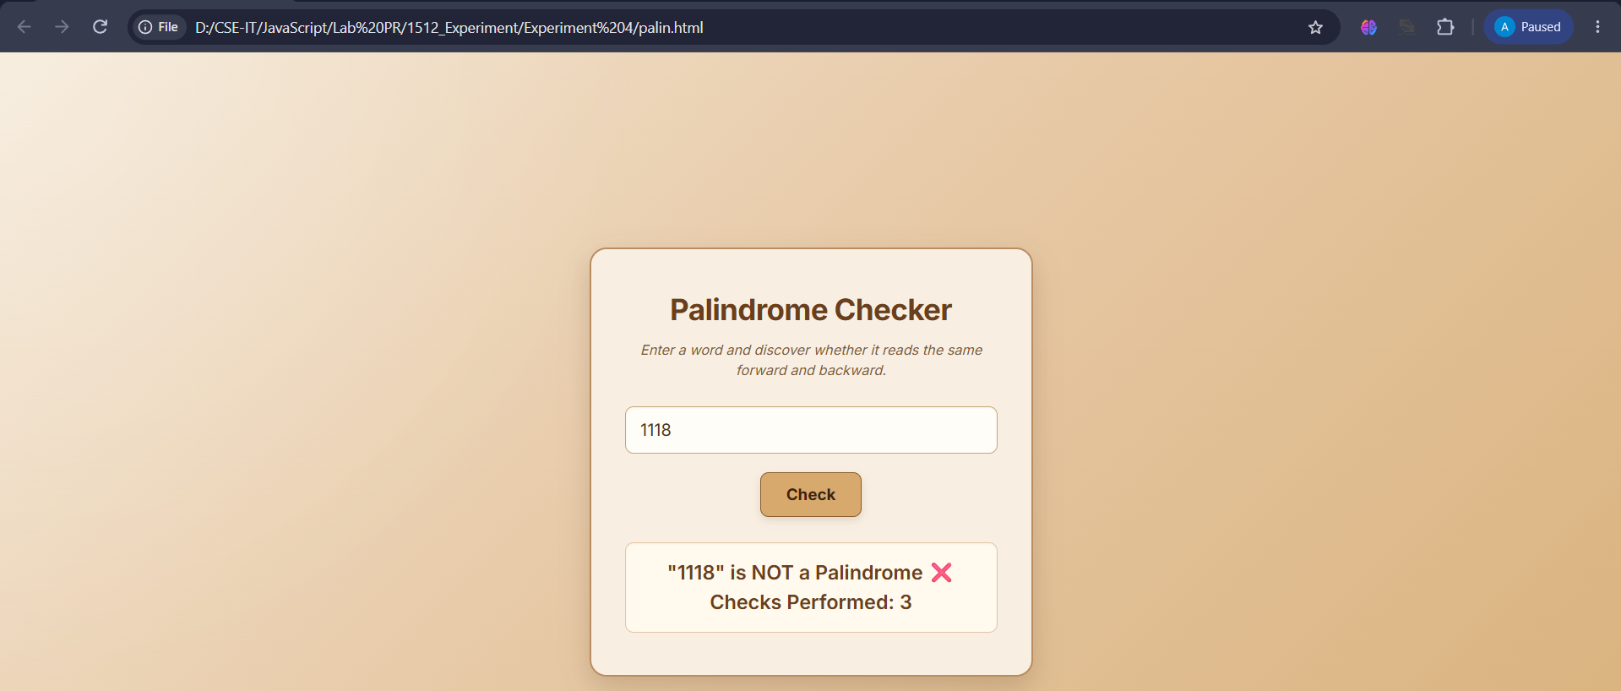

Result: Successfully implemented function types, scope, closures, and try-catch, and developed a palindrome checker that correctly identifies palindrome and non-palindrome inputs.
Conclusion: Successfully implemented functions, scope, closures, error handling, and a palindrome checker using JavaScript concepts.

